|  |
| --- |
| ITDA310 Project |
| Advanced Database Systems: Final Deliverable |
| W7MSRF657 |

|  |
| --- |
| Francois@bookwise.co.za  Francois Etienne Cloete |

Contents

Deliverable 1 2

ER Diagram 2

Data Dictionary 3

Deliverable 2: Logical Data Model 6

Derived Relations (Connolly and Begg, 2014) 6

Normalization 7

Unnormalized form 7

first normal form (removing repeating groups) (Connolly and Begg, 2014) 8

Second Normal Form (Removing partial dependencies) (Connolly and Begg, 2014) 9

Third Normal Form (Removing Transitive Dependencies) (Connolly and Begg, 2014) 11

Checking integrity Constraints 13

Required Data (Connolly and Begg, 2014) 13

Domains 15

Multiplicity 15

Entity integrity 15

Referential Integrity 15

General Cases (relating to all tables unless otherwise stated in the global data model): 15

Global Data Model 16

Global Entity Relationship Model 20

Deliverable 3: Physical Database Design 21

Base Relations Design and General Integrity Constraints 21

Pseudo Data 27

User Views 30

Security Mechanisms 31

Deliverable 4: Advanced Query Processing 38

Cursor 38

Stored Procedure 39

Function 40

Triggers 41

Deliverable 5: Database Interface Program 45

Interface 45

References 47

# Deliverable 1

## ER Diagram

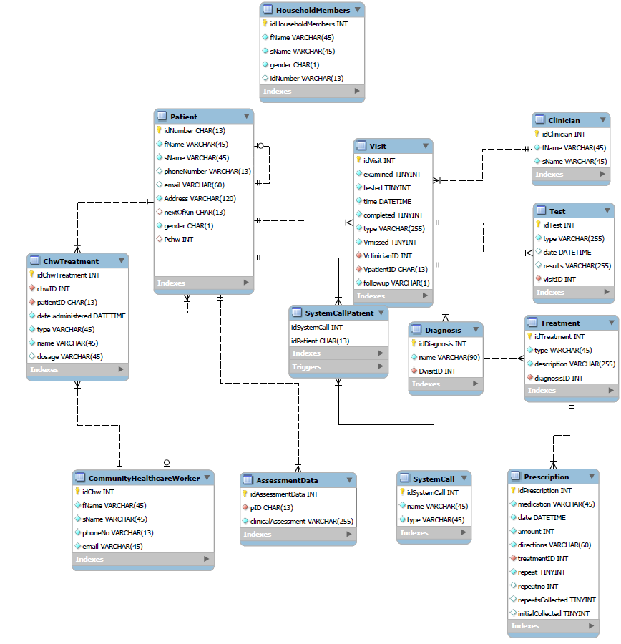

Figure : Conceptual Entity Relationship Diagram

## Data Dictionary

For a higher resolution version of the data dictionary, please open ITDA310 DD3

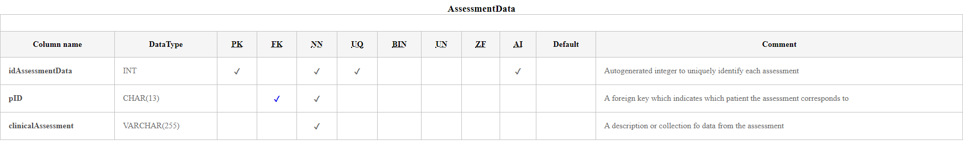

Figure : AssessmentData Entity (Castro, 2018)

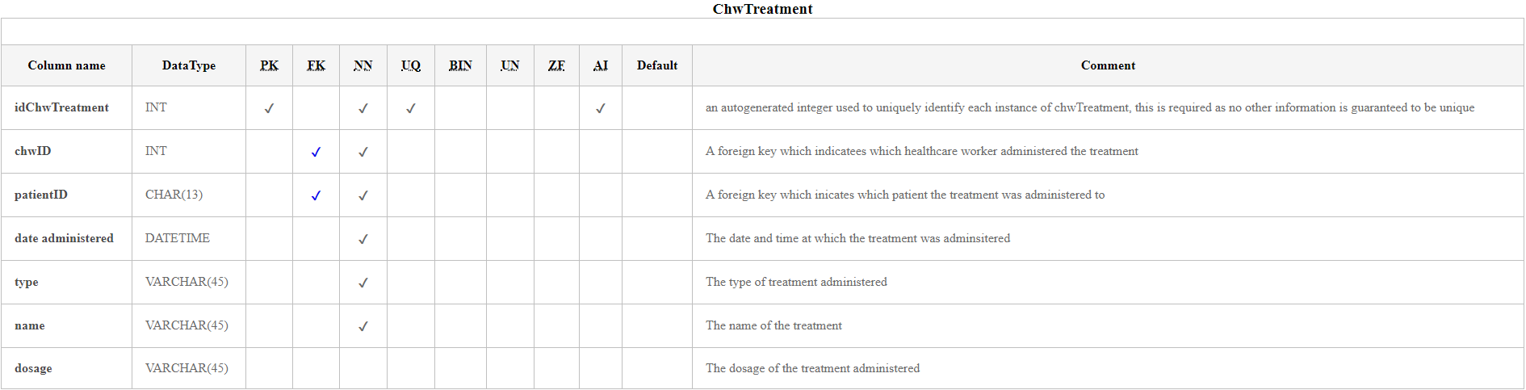

Figure : ChwTreatment Entity (Castro, 2018)

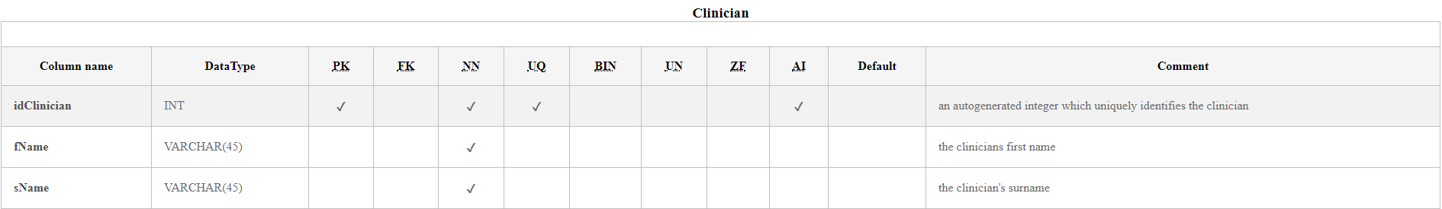

Figure : Clinician Entity (Castro, 2018)

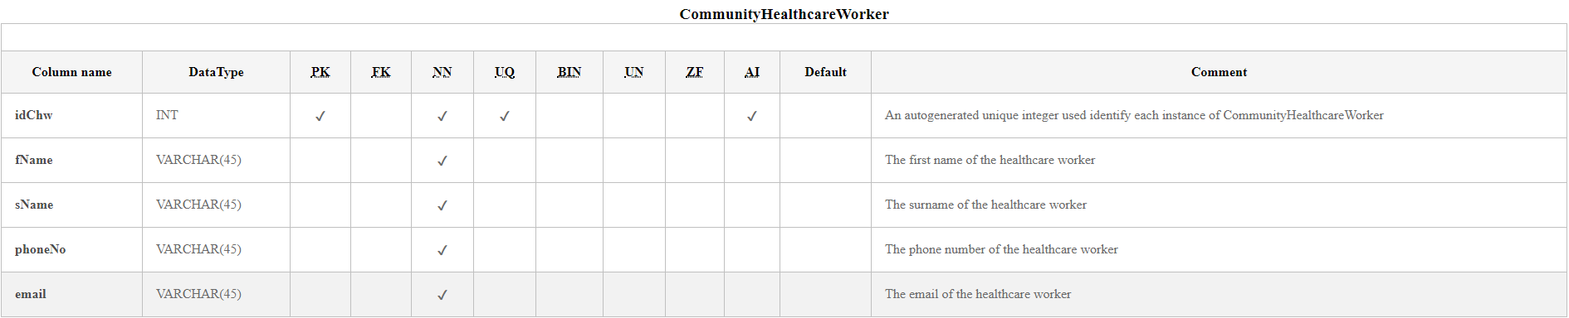

Figure : Community Healthcare Worker Entity (Castro, 2018)

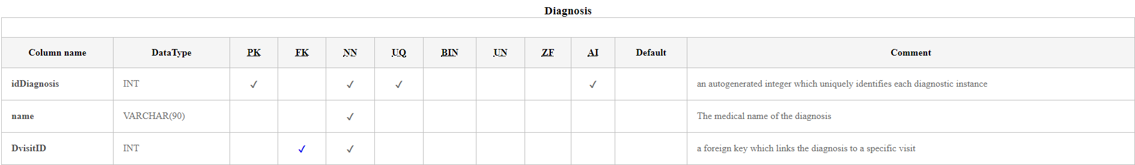

Figure : Diagnosis Entity (Castro, 2018)

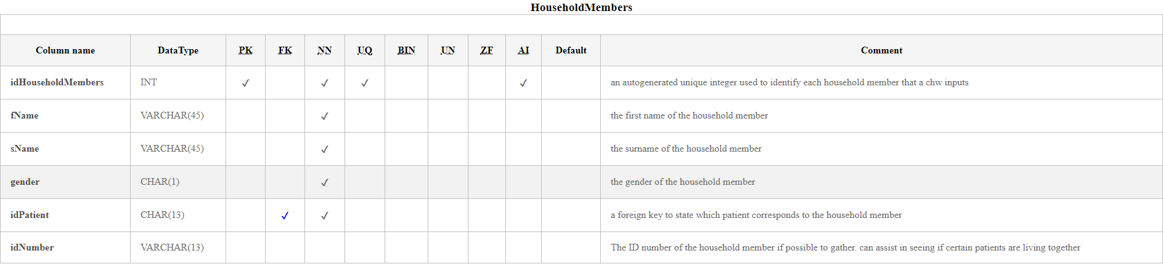

Figure : HouseholdMembers Entity (Castro, 2018)

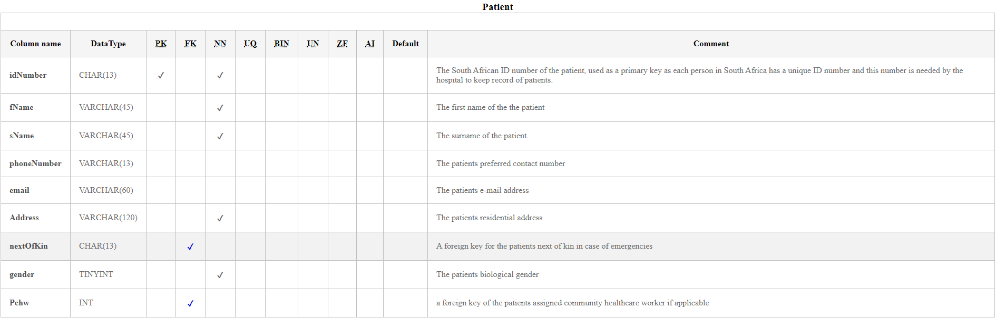

Figure : Patient Entity (Castro, 2018)

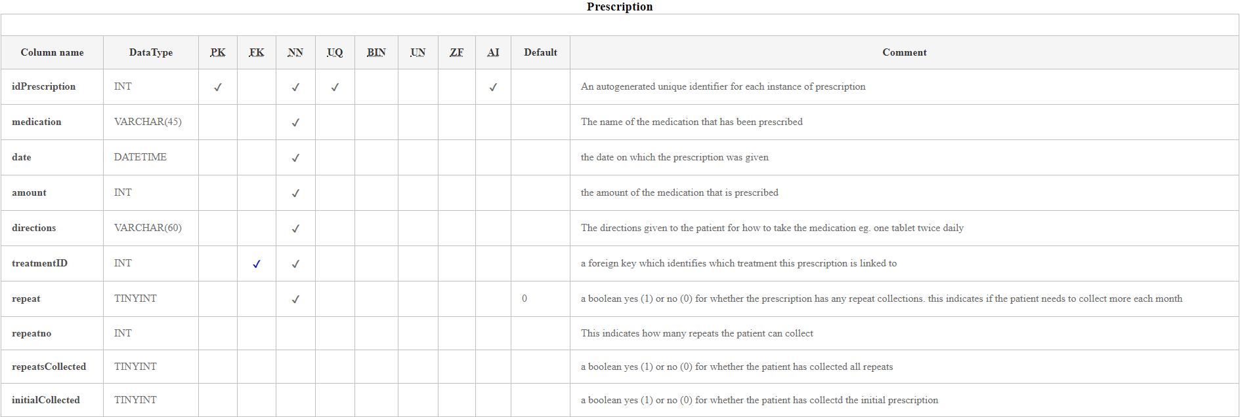

Figure : Prescription Entity (Castro, 2018)

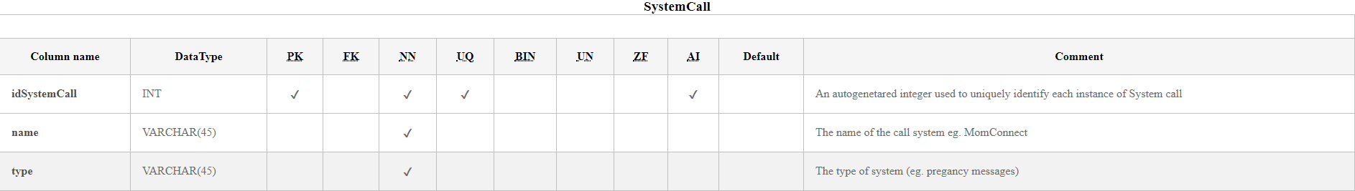

Figure : SystemCall Entity (Castro, 2018)

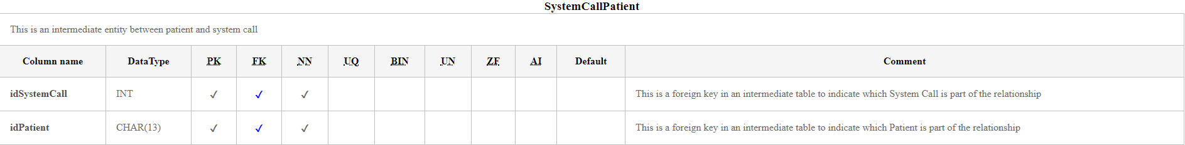

Figure : SystemCallPatient Entity (Castro, 2018)

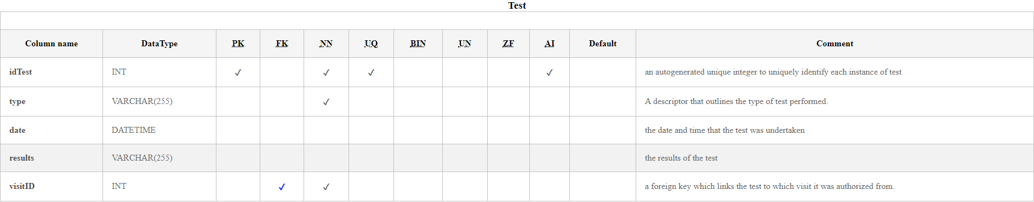

Figure : Test Entity (Castro, 2018)

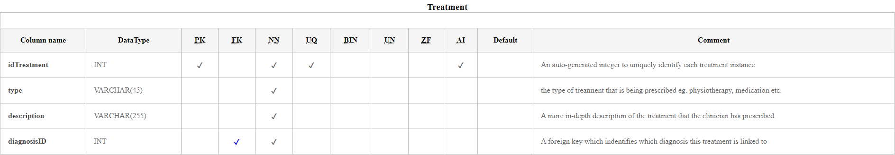

Figure : Treatment Entity (Castro, 2018)

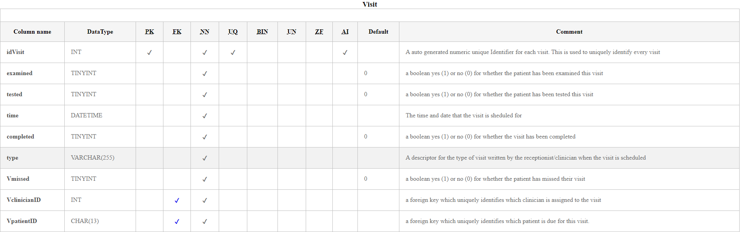

Figure : Treatment Entity (Castro, 2018)

# Deliverable 2: Logical Data Model

## Derived Relations (Connolly and Begg, 2014)

* Each Patient has one or more visits – each visit has one and only one patient (1:*)
* Each visit has one and only one clinician – each clinician has zero or more visits (1:*)
* Each visit results in zero or more lab tests – Each lab test is allocated to one and only one visit (1:*)
* Each visit results in zero or more diagnoses – Each instance of Diagnosis is assigned to one and only one visit (1:*)
* Each diagnosis has one or more treatments – each treatment is assigned to only one diagnosis (1:*)
* Each treatment has zero or more prescriptions – each prescription is allocated to only one treatment. (1:*)
* Each patient can have 0 or more system calls – each system call can have 0 or more patients (*:*)
* Each community healthcare worker looks after 1 or more patients - each patient is assigned one and only one community healthcare worker (1:*)
* Each patient has zero or more household members – each instance of household member lives with one or more patients (*:*)
* Each Patient has one and only one next of kin (registered as another patient) (1:1)
* Each Patient has 0 or more chwTreatments – each community healthcare worker administers zero or more treatments (*:*)
* Each community Healthcare Worker Capture one or more sets of Assessment Data for Each Patient – Each set of assessment data is captured by one and only one community healthcare worker (1:*)

## Normalization

### Unnormalized form

* (PK)PidNumber
* Pfname
* Psname
* Pphonenumber
* Pemail
* Paddress
* Pgender
* visitID
* Vexamined
* Vtested
* Vtime
* Vcompleted
* Vmissed
* Vtype
* ClinicianID
* Cfname
* Csname
* Testid
* Ttype
* Tdate
* Tresults
* DiagnosisID
* Dname
* TreatmentID
* Ttype
* Tdesc
* Medication
* Mdate
* Mamount
* Mdirections
* Mrepeat
* MrepeatNo
* Mrepeatscollected
* Minitialcollected
* SystemID
* SysName
* SysType
* idChw
* fname
* sname
* phoneNo
* email
* treatmentType
* treatmentDate
* treatmentName
* dosage
* hfname
* hsname
* hgender
* hidno
* idAssessmentData
* pID
* clinicalAssessment

### first normal form (removing repeating groups) (Connolly and Begg, 2014)

* (PK)PidNumber
* Pfname
* Psname
* Pphonenumber
* Pemail
* Paddress
* Pgender
* (FK)PidNumber
* (FK)systemID
* (PK)visitID
* Vexamined
* Vtested
* Vtime
* Vcompleted
* Vmissed
* Vtype
* (FK)PidNumber
* (FK)ClinicianID
* (PK)ClinicianID
* Cfname
* Csname
* (PK)Testid
* Ttype
* Tdate
* Tresults
* (FK)VisitID
* DiagnosisID
* Dname
* (FK)visitID
* TreatmentID
* Ttype
* Tdesc
* (FK)diagnosisID
* (PK)Medicationid
* Mdate
* Mamount
* Mdirections
* Mrepeat
* MrepeatNo
* Mrepeatscollected
* Minitialcollected
* (FK)treatmentID
* (PK)SystemID
* SysName
* SysType
* (PK)idChw
* fname
* sname
* phoneNo
* email
* treatmentType
* treatmentDate
* treatmentName
* dosage
* (PK)householdMemberID
* hfname
* hsname
* hgender
* hidno
* (FK)PidNumber
* (PK)idAssessmentData
* (FK)pID
* clinicalAssessment

### Second Normal Form (Removing partial dependencies) (Connolly and Begg, 2014)

* (PK)PidNumber
* Pfname
* Psname
* Pphonenumber
* Pemail
* Paddress
* Pgender
* (FK)nextOfKin
* (PK)visitID
* Vexamined
* Vtested
* Vtime
* Vcompleted
* Vmissed
* Vtype
* (FK)PidNumber
* (FK)ClinicianID
* (PK)ClinicianID
* Cfname
* Csname
* (PK)Testid
* Ttype
* Tdate
* Tresults
* (FK)VisitID
* DiagnosisID
* Dname
* (FK)visitID
* TreatmentID
* Ttype
* Tdesc
* (FK)diagnosisID
* (PK)Medicationid
* Mdate
* Mamount
* Mdirections
* Mrepeat
* MrepeatNo
* Mrepeatscollected
* Minitialcollected
* (FK)treatmentID
* (PK)SystemID
* SysName
* SysType
* (FK)SystemID
* (FK)patientID
* (PK)idChw
* fname
* sname
* phoneNo
* email
* chwTreatmentID
* treatmentType
* treatmentDate
* treatmentName
* dosage
* (FK)idChw
* (FK)PidNumber
* (PK)householdMemberID
* hfname
* hsname
* hgender
* hidno
* (FK)householdMemberID
* (FK)PidNumber
* (PK)idAssessmentData
* (FK)pID
* clinicalAssessment

### Third Normal Form (Removing Transitive Dependencies) (Connolly and Begg, 2014)

* (PK)PidNumber
* Pfname
* Psname
* Pphonenumber
* Pemail
* Paddress
* Pgender
* (FK)nextOfKin
* (PK)visitID
* Vexamined
* Vtested
* Vtime
* Vcompleted
* Vmissed
* Vtype
* (FK)PidNumber
* (FK)ClinicianID
* (PK)ClinicianID
* Cfname
* Csname
* (PK)Testid
* Ttype
* Tdate
* Tresults
* (FK)VisitID
* DiagnosisID
* Dname
* (FK)visitID
* TreatmentID
* Ttype
* Tdesc
* (FK)diagnosisID
* (PK)Medicationid
* Mdate
* Mamount
* Mdirections
* Mrepeat
* MrepeatNo
* Mrepeatscollected
* Minitialcollected
* (FK)treatmentID
* (PK)SystemID
* SysName
* SysType
* (FK)SystemID
* (FK)patientID
* (PK)idChw
* fname
* sname
* phoneNo
* email
* chwTreatmentID
* treatmentType
* treatmentDate
* treatmentName
* dosage
* (FK)idChw
* (FK)PidNumber
* (PK)householdMemberID
* hfname
* hsname
* hgender
* hidno
* (FK)householdMemberID
* (FK)PidNumber
* (PK)idAssessmentData
* (FK)pID
* clinicalAssessment

## Checking integrity Constraints

### Required Data (Connolly and Begg, 2014)

Fields that are required (separated by table):

* Assessment Data
  + idAssessmentData
  + pID
  + clinicalAssessment
* ChwTreatment
  + idChwTreatment
  + chwID
  + patientID
  + date administered
  + type
  + name
* Clinician
  + idClinician
  + fName
  + sName
* CommunityHealthcareWorker
  + idChw
  + fName
  + sName
  + phoneNo
  + email
* Diagnosis
  + idDiagnosis
  + name
  + DvisitID
* Household
  + idPatient
  + idMember
* HouseholdMembers
  + idHouseholdMembers
  + fName
  + sName
  + gender
* Patient
  + idNumber
  + fName
  + sName
  + address
  + gender
* Prescription
  + idPrescription
  + medication
  + date
  + amount
  + directions
  + treatmentID
  + repeat
* SystemCall
  + idSystemCall
  + name
  + type
* SystemCallPatient
  + idSystemCall
  + idPatient
* Test
  + idTest
  + type
  + visitID
* Treatment
  + idTreatment
  + type
  + description
  + diagnosisID
* Visit
  + idVisit
  + examined
  + tested
  + time
  + completed
  + type
  + vMissed
  + vClinicianID
  + vPatientID

### Domains

See Global Data Model

### Multiplicity

See the relationships outlined in Derived relationships above. Multiplicity is outlined at the end of each relationship. There is no cap on one to many relationships to help assure Scalability. (Connolly and Begg, 2014)

### Entity integrity

Every entity has its Primary key set to being not null to ensure entity integrity (Connolly and Begg, 2014)

### Referential Integrity

### General Cases (relating to all tables unless otherwise stated in the global data model):

(Connolly and Begg, 2014)

* Case 1: insert tuple into child relation:
  + To ensure referential integrity, check that the foreign key attributes of the new tuple are set to null if possible or to the value of an existing tuple in the parent entity
* Case 2: delete tuple from the child relation
  + If a tuple in the child relation is deleted, referential integrity is unaffected
* Case 3: update the foreign key of the child tuple
  + This is similar to case 1. To ensure referential integrity, check whether the updated foreign key is set to null or to the value of an existing staff tuple
* Case 4: insert tuple into parent relation:
  + Inserting a tuple into the parent relation does not affect referential integrity, it simply creates a parent instance without any children. Eg. A newly hired clinician who has not seen any patient yet.
* Case 5: Delete tuple from parent relation:
  + a tuple of a parent relation is deleted, referential integrity is lost if there exists a child tuple referencing the deleted parent tuple. In this case there are several strategies to consider:
    - NO ACTION – this prevents the deletion of a parent tuple if it has child tuples
    - CASCADE – When the parent tuple is deleted, all referring child tuples will also be deleted
    - SET NULL – When a parent tuple is deleted, the foreign key values in child tuples are set to null
    - SET DEFAULT - When a parent tuple is deleted, the foreign key value in any child tuples will be set to a default value
    - NO CHECK – when a parent tuple is deleted, nothing is done to child tuples to ensure referential integrity.
  + For the use case in this database, a combination of NO ACTION and CASCADE will be use depending on the relationships in question. NO ACTION will ensure that child records need to be manually deleted if seen as irrelevant or will need to be manually updated to a new parent relation. Cascading deletes will be used sparingly and only in situations where valuable information cannot be lost through a cascade (for example, with patients and household members linking to them).
* Case 6: Updating the primary key of the parent tuple
  + If the primary key value is updated in a parent tuple, referential integrity would be lost if it has any child relations referencing the old primary key value. In this case Cascade will be used as stated above to ensure that child tuples are automatically updated to reflect the new primary key of the parent tuple

## Global Data Model

For a higher Resolution version see ITDA310 DDL.html

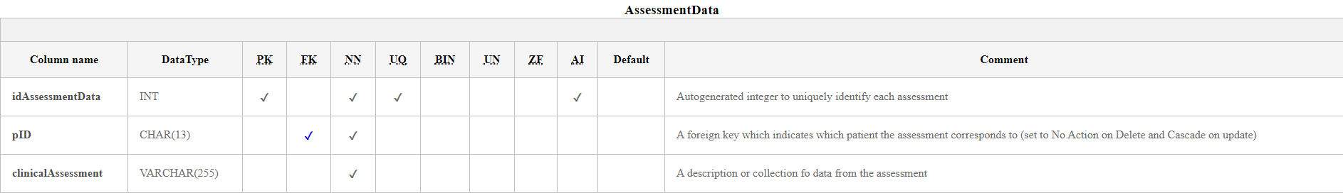

Figure : AssessmentData Entity (Castro, 2018)

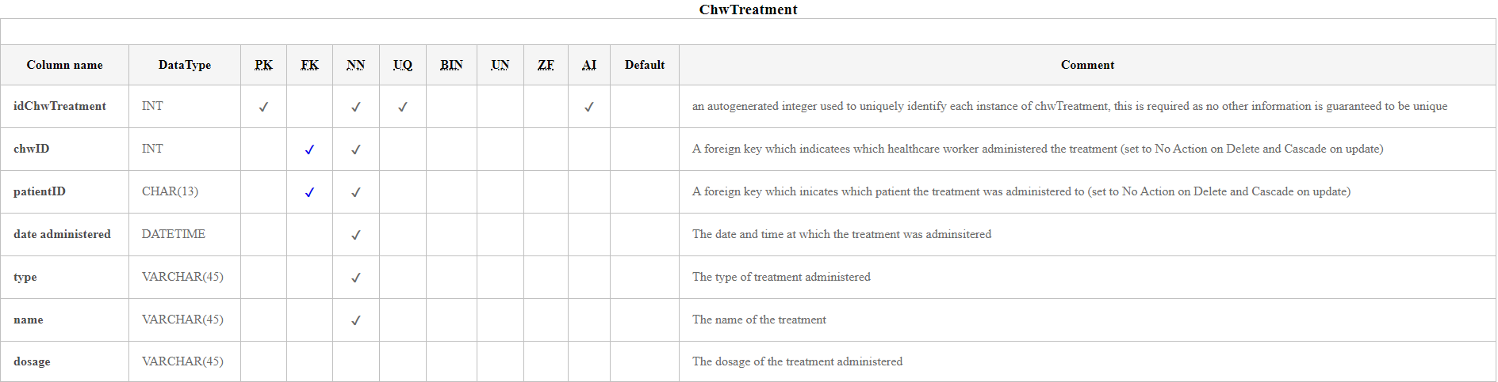

Figure :ChwTreatment Entity (Castro, 2018)

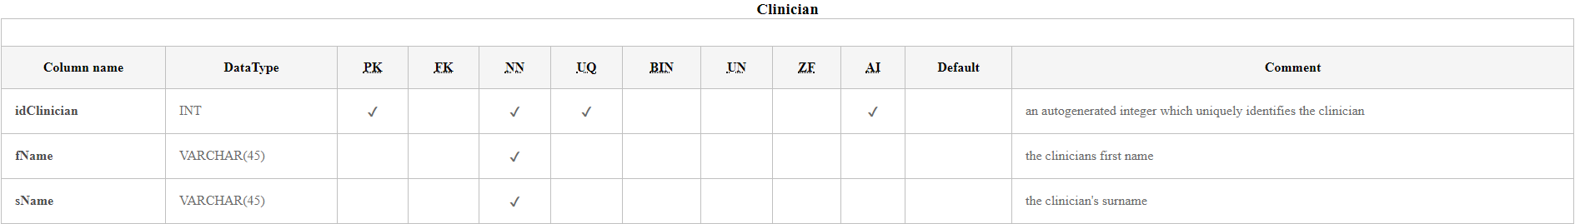

Figure : Clinician Entity (Castro, 2018)

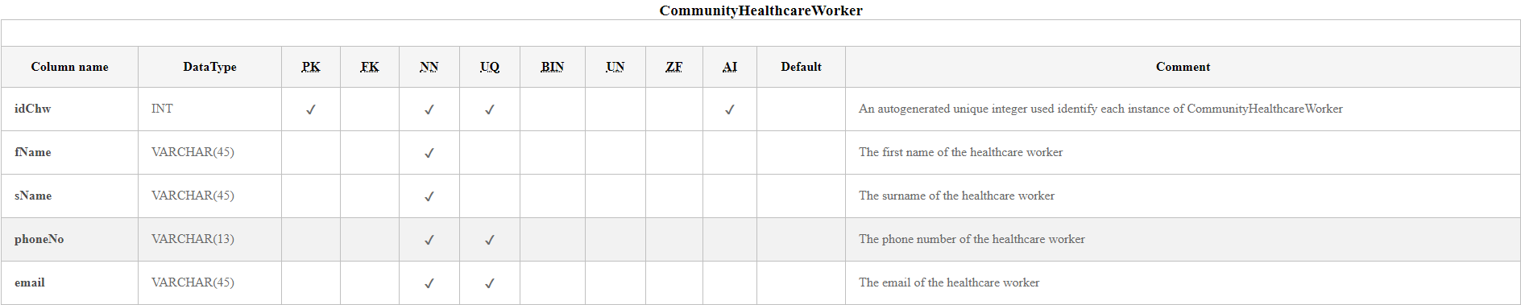

Figure : CommunityHealthcareWorker Entity (Castro, 2018)

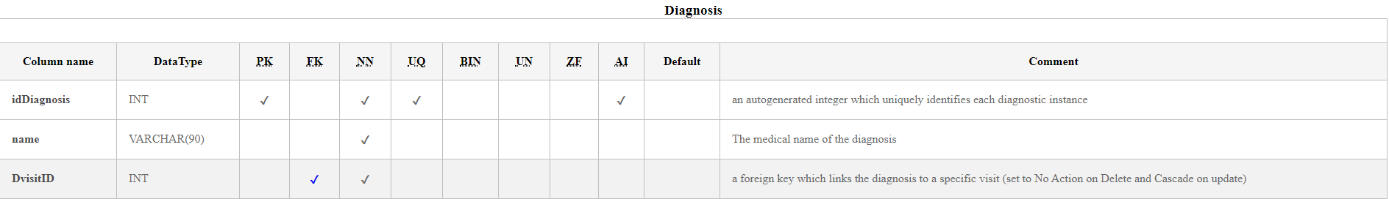

Figure : Diagnosis Entity (Castro, 2018)

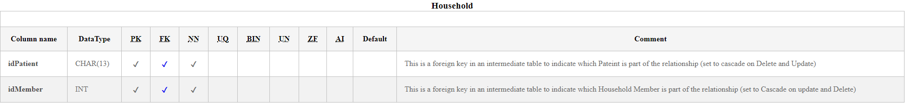

Figure : Household Entity (Castro, 2018)

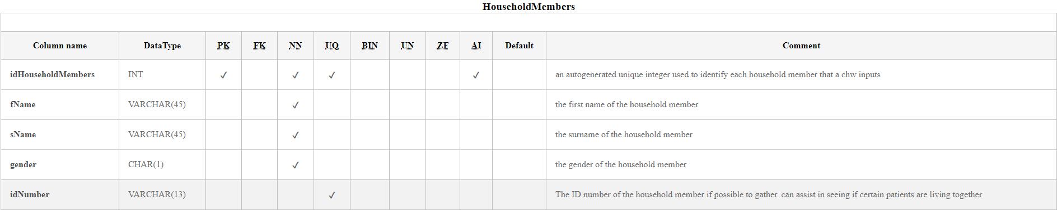

Figure : HouseholdMembers Entity (Castro, 2018)

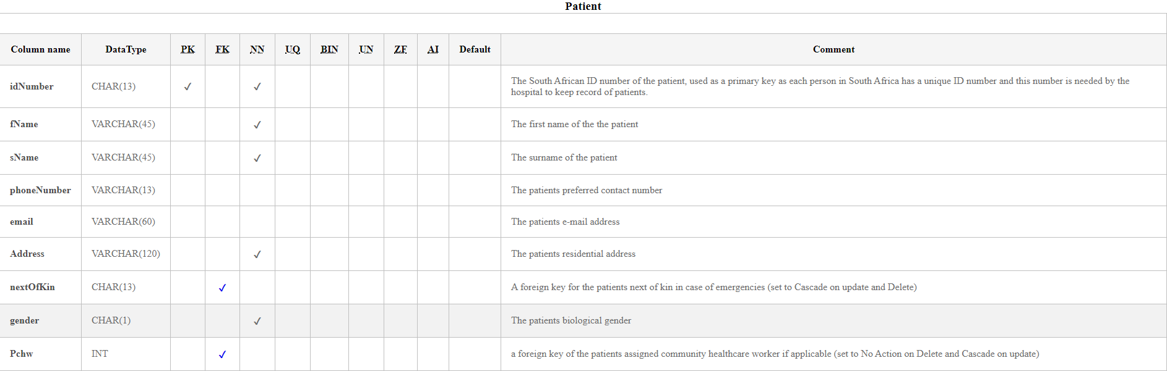

Figure : Patient Entity (Castro, 2018)

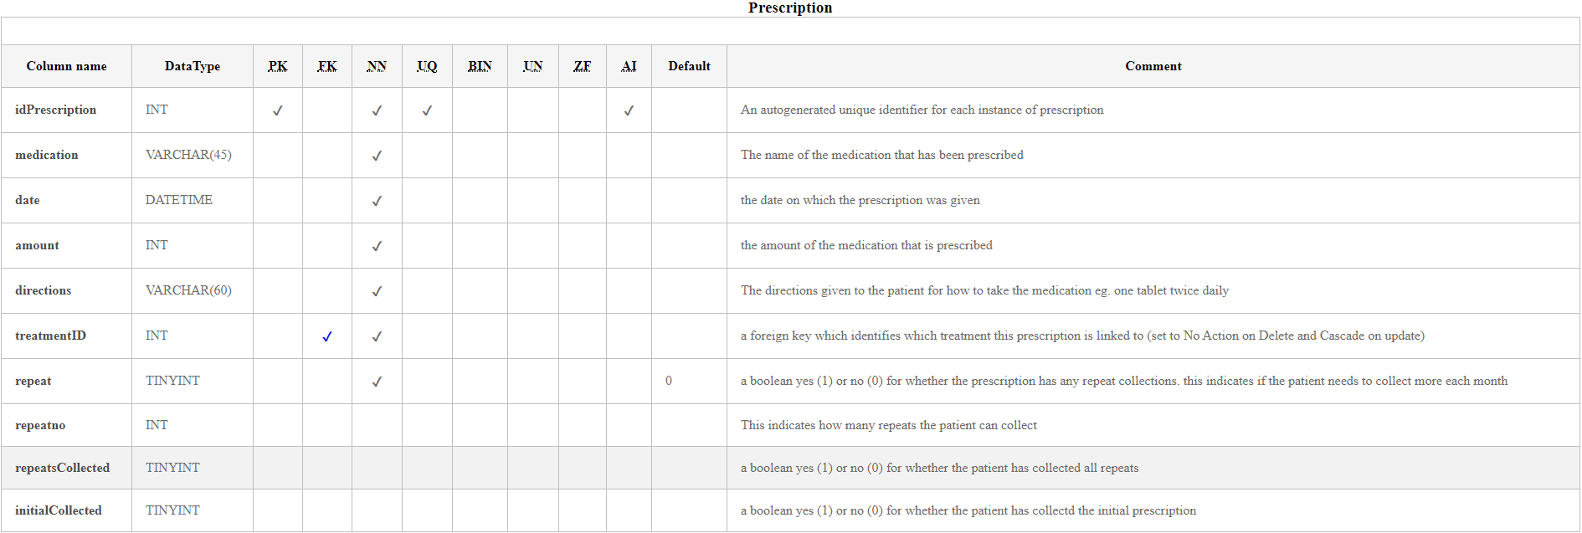

Figure : Prescription Entity (Castro, 2018)

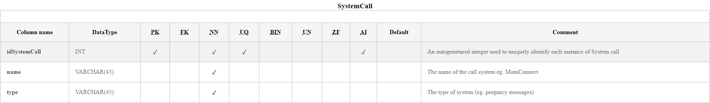

Figure : SystemCall Entity (Castro, 2018)

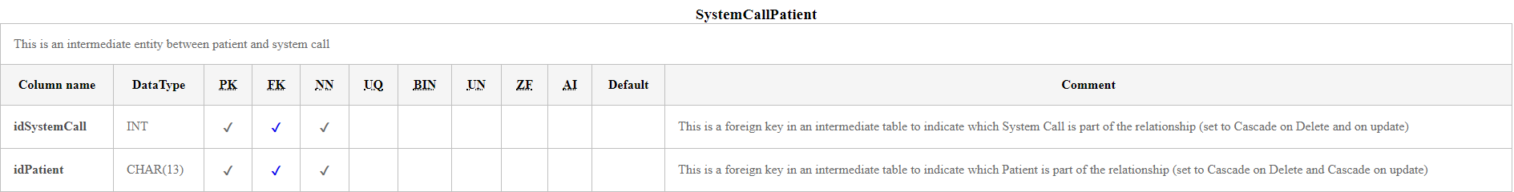

Figure :SystemCallPatient Entity (Castro, 2018)

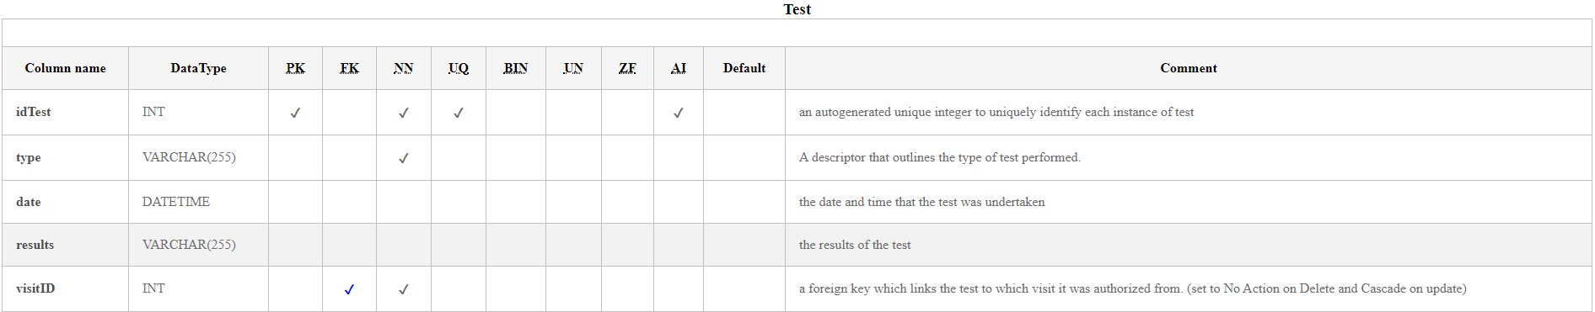

Figure : Test Entity (Castro, 2018)

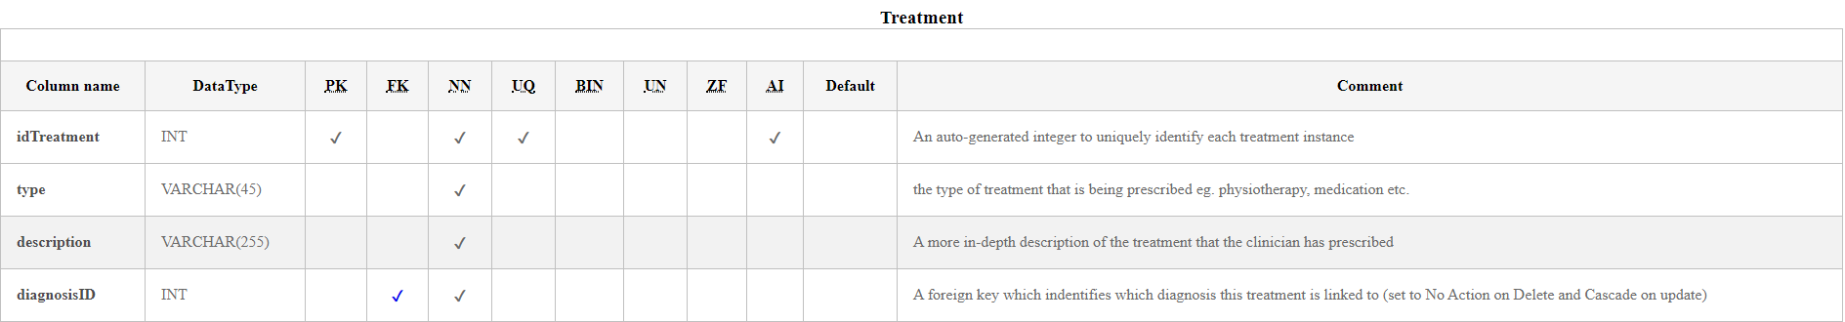

Figure : Treatment Entity (Castro, 2018)

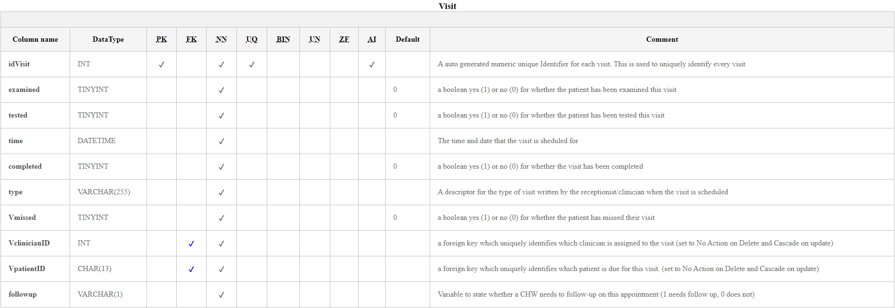

Figure : Visit Entity (Castro, 2018)

## Global Entity Relationship Model

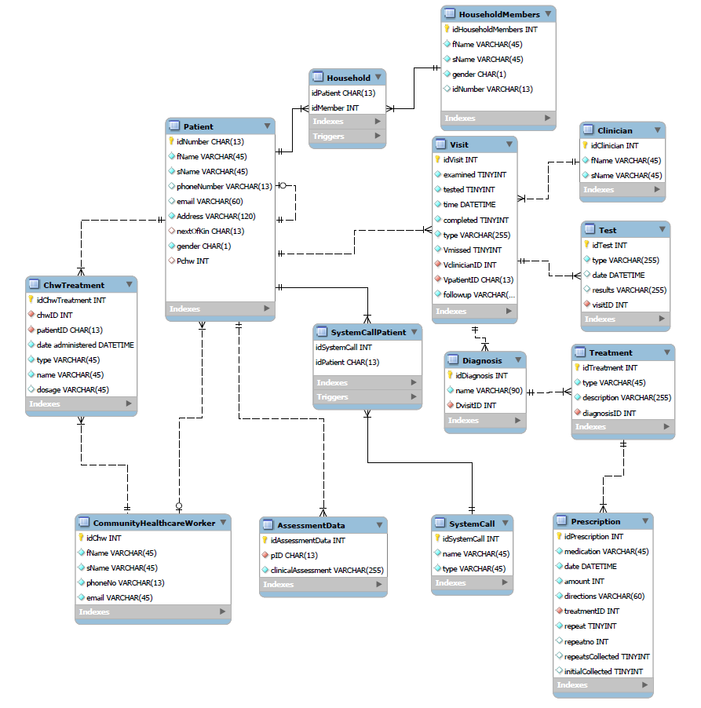

Figure : Global Entity Relationship Diagram

# Deliverable 3: Physical Database Design

## Base Relations Design and General Integrity Constraints

Figure :Schema Settings for Database

Figure : base relations and integrity constraints for AssessmentData

Figure :Base Relations and Integrity Constraints for CommunityHealthcareWorker

Figure : Alteration to Add Missing Comment for Phone Number in Community Healthcare Worker

Figure : Base Relations and Integrity Constraints for ChwTreatment

Figure : Base Relations and Integrity Constraints for Clinician

Figure : Base Relations and Integrity Constraints for Diagnosis

Figure : Base Relations and Integrity Constraints for Household

Figure : Base Relations and Integrity Constraints for HouseholdMembers

Figure :Base Relations and Integrity Constraints for Patient

Figure : Base Relations and Integrity Constraints for Prescription

Figure : Base Relations and Integrity Constraints for System Call

Figure : Base Relations and Integrity Constraints for SystemCallPatient

Figure : Base Relations and Integrity Constraints for Test

Figure : Base Relations and Integrity Constraints for Treatment

Figure : Base Relations and Integrity Constraints for Visit

## Pseudo Data

Figure :Sample Data for AssessmentData

Figure :Sample Data for CommunityHealthcareWorker

Figure :Sample Data for ChwTreatment

Figure :Sample Data for Clinician

Figure ::Sample Data for Diagnosis

Figure : :Sample Data for HouseholdMembers

Figure : :Sample Data for Household

Figure : :Sample Data for Patient



Figure : :Sample Data for Prescription

Figure : :Sample Data for SystemCall

Figure :Sample Data for SystemCallPatient

Figure : Sample Data for Test

Figure :Sample Data for Treatment

Figure :Sample Data for Visit

## User Views

Figure : SQL Code to display which patients require a follow up from a CHW



Figure : Output for Follow-up View

Figure : Code To Display Which Precriptions Belong To Which Patients By Their ID numbers (Avila, 2014)



Figure : Output of Prescription View

## Security Mechanisms

Figure : User list in MySQL (MySQL :: MySQL 8.0 Reference Manual :: 6.1.3 Making MySQL Secure Against Attackers, 2020)

Figure : MySQL Login Request (MySQL :: MySQL 8.0 Reference Manual :: 6.1.3 Making MySQL Secure Against Attackers, 2020)

Figure : Root Password Settings (MySQL :: MySQL 8.0 Reference Manual :: 6.1.3 Making MySQL Secure Against Attackers, 2020)

Figure : Password Settings for Community Healthcare Worker (MySQL :: MySQL 8.0 Reference Manual :: 6.1.3 Making MySQL Secure Against Attackers, 2020)

Figure : Password Settings for Clinician (MySQL :: MySQL 8.0 Reference Manual :: 6.1.3 Making MySQL Secure Against Attackers, 2020)

Figure : Password Settings for Pharmacist (MySQL :: MySQL 8.0 Reference Manual :: 6.1.3 Making MySQL Secure Against Attackers, 2020)

Figure : Password Settings for Receptionist (MySQL :: MySQL 8.0 Reference Manual :: 6.1.3 Making MySQL Secure Against Attackers, 2020)

Figure : Permission Grant Statements For All Above Users (MySQL :: MySQL 8.0 Reference Manual :: 6.1.3 Making MySQL Secure Against Attackers, 2020) (MySQL: Grant/Revoke Privileges, n.d.)

# Deliverable 4: Advanced Query Processing

## Cursor

Figure : Code to Create a Cursor Which Accesses Query Results One-By-One (Gravelle, 2013) (MySQL :: MySQL 8.0 Reference Manual :: B.4.6.2 TEMPORARY Table Problems, 2020) (Working with Cursors : MySQL, 2020)

Figure : Outputs for the Cursor (Note the Multiple Results Tab)

## Stored Procedure

Figure :Stored Procedure Code

Figure :Stored Procedure Output

## Function

Figure :Stored Function Code (Black, 2011) (Martinez, 2012) (MySQL :: MySQL 5.7 Reference Manual :: 23.7 Stored Program Binary Logging, 2020) (MySQL :: MySQL 8.0 Reference Manual :: 13.7.4.1 CREATE FUNCTION Syntax for User-Defined Functions, 2020)

Figure :Stored Function Output

## Triggers

Figure : Triggers on the Patient Table to Ensure Valid Information (Razzoli, 2012)

Figure : Trigger Forcing an Error Due to an Invalid Email

Figure : Trigger Forcing an Error Due to an Invalid Phone Number

Figure : Trigger to Ensure Parent Entity Exists for Older Versions of MySQL (Razzoli, 2012)

Figure :Trigger to Ensure Parent Entity Exists for Older Versions of MySQL (Razzoli, 2012)

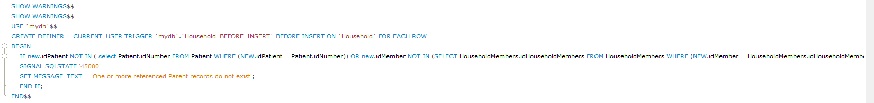

Figure :Trigger to Ensure Parent Entity Exists for Older Versions of MySQL (Razzoli, 2012)

Figure :Trigger to Ensure Parent Entity Exists for Older Versions of MySQL (Razzoli, 2012)

# Deliverable 5: Database Interface Program

# Interface

Figure : Initial Interface on Load. Displays Whether the Database Managed to Connect.

Figure : Community Healthcare Worker View After Selecting a CHW Number and Clicking Fetch Data (Dickson, 2011)

Figure : Prescription View Which is Automatically Refreshed When the Tab is Selected (TabPage Click Events, 2012)

# References

Avila, P., 2014. *Exploring Join Paths; The Key To Building Multiple-Table Joins - Interface Technical Training*. [online] Interface Technical Training. Available at: <https://www.interfacett.com/blogs/exploring-join-paths-the-key-to-building-multiple-table-joins/> [Accessed 26 May 2020].

Black, J., 2011. *Creating Temporary Tables In Mysql Stored Procedure*. [online] Stack Overflow. Available at: <https://stackoverflow.com/questions/5308969/creating-temporary-tables-in-mysql-stored-procedure> [Accessed 27 May 2020].

Castro, R., 2018. *4 Database Documentation / Data Dictionary Generator Plugins For Mysql Workbench - Mysql Workbench Tutorials*. [online] Dataedo.com. Available at: <https://dataedo.com/kb/tools/mysql-workbench/documentation-generator-plugins> [Accessed 21 April 2020].

Connolly, T. and Begg, C., 2014. *Database Systems: A Practical Approach To Design, Implementation, And Management: Global Edition*. 6th ed. Harlow: Pearson Education, pp.503-583.

Dickson, A., 2011. *Mysql Returns Only One Row*. [online] Stack Overflow. Available at: <https://stackoverflow.com/questions/4372197/mysql-returns-only-one-row> [Accessed 28 May 2020].

Gravelle, R., 2013. *Mysql Cursors And Loops — Databasejournal.Com*. [online] Databasejournal.com. Available at: <https://www.databasejournal.com/features/mysql/mysql-cursors-and-loops.html> [Accessed 27 May 2020].

Martinez, P., 2012. *Mysql Error When Adding Function*. [online] Stack Overflow. Available at: <https://stackoverflow.com/questions/11316008/mysql-error-when-adding-function> [Accessed 27 May 2020].

Dev.mysql.com. 2020. *Mysql :: Mysql 5.7 Reference Manual :: 23.7 Stored Program Binary Logging*. [online] Available at: <https://dev.mysql.com/doc/refman/5.7/en/stored-programs-logging.html> [Accessed 27 May 2020].

Dev.mysql.com. 2020. *Mysql :: Mysql 8.0 Reference Manual :: 13.7.4.1 CREATE FUNCTION Syntax For User-Defined Functions*. [online] Available at: <https://dev.mysql.com/doc/refman/8.0/en/create-function-udf.html> [Accessed 27 May 2020].

Dev.mysql.com. 2020. *Mysql :: Mysql 8.0 Reference Manual :: 6.1.3 Making Mysql Secure Against Attackers*. [online] Available at: <https://dev.mysql.com/doc/refman/8.0/en/security-against-attack.html> [Accessed 26 May 2020].

Dev.mysql.com. 2020. *Mysql :: Mysql 8.0 Reference Manual :: B.4.6.2 TEMPORARY Table Problems*. [online] Available at: <https://dev.mysql.com/doc/refman/8.0/en/temporary-table-problems.html> [Accessed 27 May 2020].

Techonthenet.com. n.d. *Mysql: Grant/Revoke Privileges*. [online] Available at: <https://www.techonthenet.com/mysql/grant_revoke.php> [Accessed 26 May 2020].

Razzoli, F., 2012. *Validating Data Using A TRIGGER*. [online] FALSE IS NOT NULL. Available at: <https://falseisnotnull.wordpress.com/2012/11/06/validating-data-using-a-trigger/> [Accessed 23 May 2020].

Stack Overflow. 2012. *Tabpage Click Events*. [online] Available at: <https://stackoverflow.com/questions/9684221/tabpage-click-events> [Accessed 28 May 2020].

Brainbell.com. 2020. *Working With Cursors : Mysql*. [online] Available at: <https://www.brainbell.com/tutorials/MySQL/Working_With_Cursors.htm> [Accessed 26 May 2020].